|  |  |  |  |  |  |  |
| --- | --- | --- | --- | --- | --- | --- |
|  | **יום ראשון** | **יום שני** | **יום שלישי** | **יום רביעי** | **יום חמישי** | **יום שישי** |
|  |  |  |  |  |  |  |
|  |  |  |  |  |  |  |
|  |  |  |  |  |  |  |
|  |  |  |  |  |  |  |
|  |  |  |  |  |  |  |
|  |  |  |  |  |  |  |
|  |  |  |  |  |  |  |

[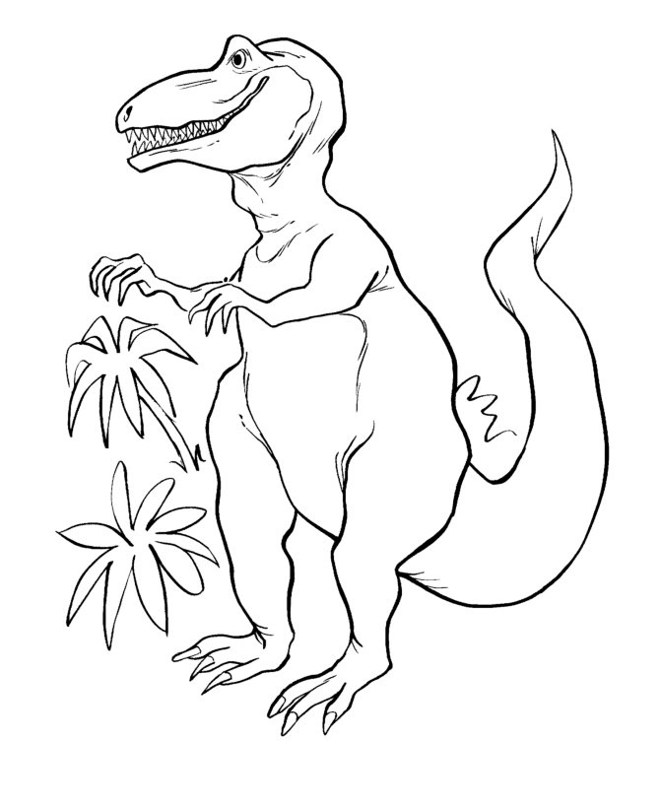](http://www.google.co.il/url?sa=i&rct=j&q=&esrc=s&frm=1&source=images&cd=&cad=rja&docid=o_M03s4q0r-KuM&tbnid=StDWjbNY_gTQAM:&ved=0CAUQjRw&url=http%3A%2F%2Fwww.printime.co.il%2F16584%2F%25D7%2593%25D7%25A4%25D7%2599-%25D7%25A6%25D7%2591%25D7%2599%25D7%25A2%25D7%2594-%25D7%259C%25D7%2594%25D7%2593%25D7%25A4%25D7%25A1%25D7%2594-%25D7%25A9%25D7%259C-%25D7%2593%25D7%2599%25D7%25A0%25D7%2595%25D7%2596%25D7%2590%25D7%2595%25D7%25A8%25D7%2599%25D7%259D&ei=O9KEUqCzC8PItQbjr4GQBg&psig=AFQjCNF5qVInmn8c0ldL2WDEIhTReIdp5Q&ust=1384522336713797)[](http://www.printime.co.il/image/users/16584/ftp/my_files/tubishvat3.gif?id=9599641)[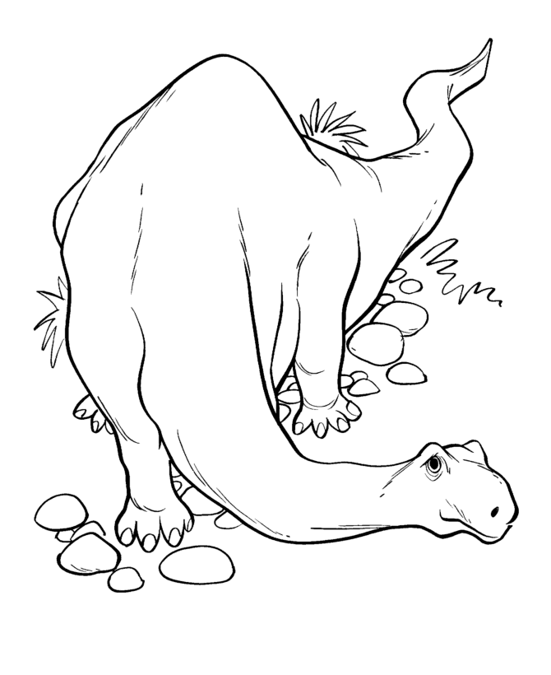](http://www.google.co.il/url?sa=i&rct=j&q=&esrc=s&frm=1&source=images&cd=&cad=rja&docid=o_M03s4q0r-KuM&tbnid=223S8iBVH3U3vM:&ved=0CAUQjRw&url=http%3A%2F%2Fwww.printime.co.il%2F16584%2F%25D7%2593%25D7%25A4%25D7%2599-%25D7%25A6%25D7%2591%25D7%2599%25D7%25A2%25D7%2594-%25D7%259C%25D7%2594%25D7%2593%25D7%25A4%25D7%25A1%25D7%2594-%25D7%25A9%25D7%259C-%25D7%2593%25D7%2599%25D7%25A0%25D7%2595%25D7%2596%25D7%2590%25D7%2595%25D7%25A8%25D7%2599%25D7%259D&ei=_tGEUsSqPIzNsga-x4DoAw&psig=AFQjCNF5qVInmn8c0ldL2WDEIhTReIdp5Q&ust=1384522336713797)[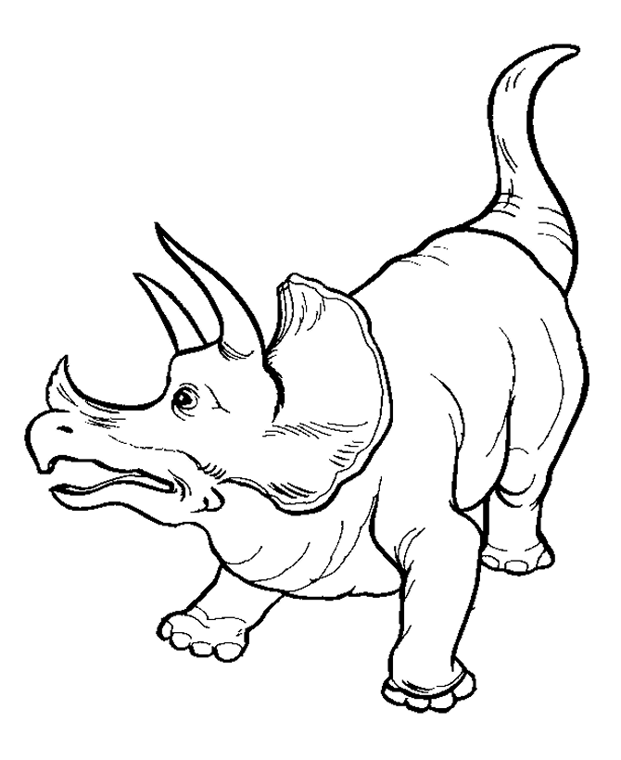](http://www.printime.co.il/image/users/16584/ftp/my_files/dinosaur12.gif?id=3647092)

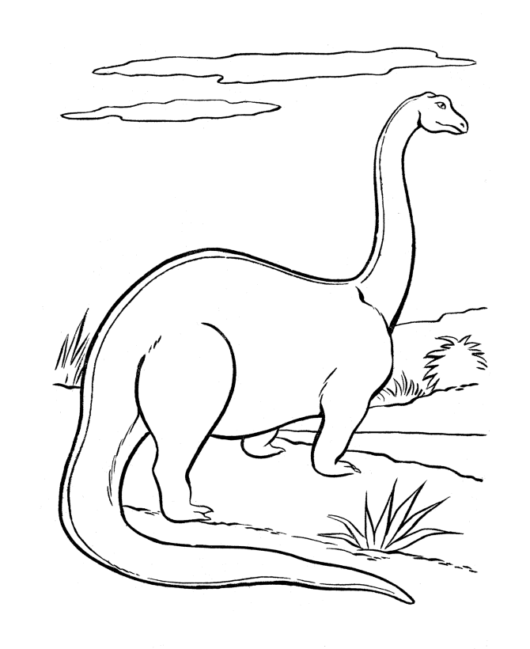[](http://www.printime.co.il/image/users/16584/ftp/my_files/tubishvat3.gif?id=9599641)[](http://www.google.co.il/imgres?start=115&biw=1920&bih=912&tbm=isch&tbnid=aNpe1xYXqDyJJM:&imgrefurl=http://www.printime.co.il/16584/%25D7%2593%25D7%25A4%25D7%2599-%25D7%25A6%25D7%2591%25D7%2599%25D7%25A2%25D7%2594-%25D7%259C%25D7%2594%25D7%2593%25D7%25A4%25D7%25A1%25D7%2594-%25D7%25A9%25D7%259C-%25D7%2593%25D7%2599%25D7%25A0%25D7%2595%25D7%2596%25D7%2590%25D7%2595%25D7%25A8%25D7%2599%25D7%259D&docid=o_M03s4q0r-KuM&imgurl=http://www.printime.co.il/image/users/16584/ftp/my_files/dinosaur1.gif%253Fid%253D3647066&w=670&h=820&ei=kNCEUp7FHIKDtAaJqoGYCA&zoom=1&ved=1t:3588,r:26,s:100,i:82&iact=rc&page=4&tbnh=186&tbnw=146&ndsp=42&tx=107&ty=93)

[](http://www.printime.co.il/image/users/16584/ftp/my_files/dinosaur12.gif?id=3647092)[](http://www.google.co.il/url?sa=i&rct=j&q=&esrc=s&frm=1&source=images&cd=&cad=rja&docid=o_M03s4q0r-KuM&tbnid=223S8iBVH3U3vM:&ved=0CAUQjRw&url=http%3A%2F%2Fwww.printime.co.il%2F16584%2F%25D7%2593%25D7%25A4%25D7%2599-%25D7%25A6%25D7%2591%25D7%2599%25D7%25A2%25D7%2594-%25D7%259C%25D7%2594%25D7%2593%25D7%25A4%25D7%25A1%25D7%2594-%25D7%25A9%25D7%259C-%25D7%2593%25D7%2599%25D7%25A0%25D7%2595%25D7%2596%25D7%2590%25D7%2595%25D7%25A8%25D7%2599%25D7%259D&ei=_tGEUsSqPIzNsga-x4DoAw&psig=AFQjCNF5qVInmn8c0ldL2WDEIhTReIdp5Q&ust=1384522336713797)

|  |  |  |  |  |  |  |
| --- | --- | --- | --- | --- | --- | --- |
|  | **יום ראשון** | **יום שני** | **יום שלישי** | **יום רביעי** | **יום חמישי** | **יום שישי** |
|  |  |  |  |  |  |  |
|  |  |  |  |  |  |  |
|  |  |  |  |  |  |  |
|  |  |  |  |  |  |  |
|  |  |  |  |  |  |  |
|  |  |  |  |  |  |  |
|  |  |  |  |  |  |  |

[](http://www.printime.co.il/image/users/16584/ftp/my_files/tubishvat3.gif?id=9599641)[](http://www.google.co.il/url?sa=i&rct=j&q=&esrc=s&frm=1&source=images&cd=&cad=rja&docid=o_M03s4q0r-KuM&tbnid=StDWjbNY_gTQAM:&ved=0CAUQjRw&url=http%3A%2F%2Fwww.printime.co.il%2F16584%2F%25D7%2593%25D7%25A4%25D7%2599-%25D7%25A6%25D7%2591%25D7%2599%25D7%25A2%25D7%2594-%25D7%259C%25D7%2594%25D7%2593%25D7%25A4%25D7%25A1%25D7%2594-%25D7%25A9%25D7%259C-%25D7%2593%25D7%2599%25D7%25A0%25D7%2595%25D7%2596%25D7%2590%25D7%2595%25D7%25A8%25D7%2599%25D7%259D&ei=O9KEUqCzC8PItQbjr4GQBg&psig=AFQjCNF5qVInmn8c0ldL2WDEIhTReIdp5Q&ust=1384522336713797)[](http://www.google.co.il/imgres?start=115&biw=1920&bih=912&tbm=isch&tbnid=aNpe1xYXqDyJJM:&imgrefurl=http://www.printime.co.il/16584/%25D7%2593%25D7%25A4%25D7%2599-%25D7%25A6%25D7%2591%25D7%2599%25D7%25A2%25D7%2594-%25D7%259C%25D7%2594%25D7%2593%25D7%25A4%25D7%25A1%25D7%2594-%25D7%25A9%25D7%259C-%25D7%2593%25D7%2599%25D7%25A0%25D7%2595%25D7%2596%25D7%2590%25D7%2595%25D7%25A8%25D7%2599%25D7%259D&docid=o_M03s4q0r-KuM&imgurl=http://www.printime.co.il/image/users/16584/ftp/my_files/dinosaur1.gif%253Fid%253D3647066&w=670&h=820&ei=kNCEUp7FHIKDtAaJqoGYCA&zoom=1&ved=1t:3588,r:26,s:100,i:82&iact=rc&page=4&tbnh=186&tbnw=146&ndsp=42&tx=107&ty=93)[](http://www.printime.co.il/image/users/16584/ftp/my_files/tubishvat3.gif?id=9599641)